Tower of Hanoi
print(“Tower Of Hanoi”)
def tower_of_hanoi(n, source, auxiliary, destination):
if n == 1:
print(f"Move disk 1 from {source} to {destination}")
return
tower_of_hanoi(n-1, source, auxiliary, destination)
print(f"Move disk {n} from {source} to {destination}")
tower_of_hanoi(n-1, auxiliary, source, destination)

# Ask the user for the number of disks
num_disks = int(input("Enter the number of disks: "))

# Initial call to the function with source 'A', auxiliary 'B', and destination 'C'
tower_of_hanoi(num_disks, 'A', 'B', 'C')
Output:
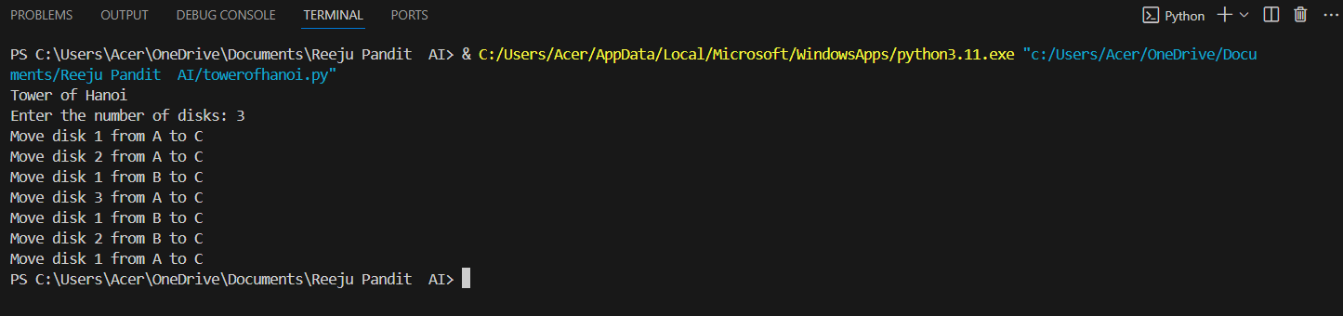

Compiler: Visual Studio Code
Language: Python

Water Jug Problem

print("Water Jug Problem")
# Initial values for the jugs
x = int(input("Enter the initial amount in Jug1 (x): "))
y = int(input("Enter the initial amount in Jug2 (y): "))
while True:
print("Rules:")
print("1. Fill Jug1 to its capacity (4 liters)")
print("2. Fill Jug2 to its capacity (3 liters)")
print("5. Empty Jug1")
print("6. Empty Jug2")
print("7. Pour water from Jug2 to Jug1 until Jug1 is full or Jug2 is empty")
print("8. Pour water from Jug1 to Jug2 until Jug2 is full or Jug1 is empty")
print("9. Pour all water from Jug2 into Jug1")
print("10. Pour all water from Jug1 into Jug2")

r = int(input("Enter the rule number (1-10): "))

if r == 1:
if x < 4: # Fill Jug1 to its capacity (4 liters)
x = 4
elif r == 2:
if y < 3: # Fill Jug2 to its capacity (3 liters)
y = 3
elif r == 5:
if x > 0: # Empty Jug1
x = 0

elif r == 6:
if y > 0: # Empty Jug2
y = 0
elif r == 7:
if x + y >= 4 and y > 0:
# Pour water from Jug2 to Jug1 until Jug1 is full or Jug2 is empty
x, y = min(4, x + y), max(0, y - (4 - x))
elif r == 8:
if x + y >= 3 and x > 0:
# Pour water from Jug1 to Jug2 until Jug2 is full or Jug1 is empty
x, y = max(0, x - (3 - y)), min(3, x + y)
elif r == 9:
if x + y <= 4 and y > 0: # Pour all water from Jug2 into Jug1
x, y = x + y, 0
elif r == 10:
if x + y <= 3 and x > 0: # Pour all water from Jug1 into Jug2
x, y = 0, x + y
else:
print("Invalid rule number. Please try again.")

# Display the current state of both jugs
print("x =", x)
print("y =", y)

# Check if the goal state (2 liters in Jug1) is reached
if x == 2 and y == 0:
print("The result is a Goal State")
break

Output:
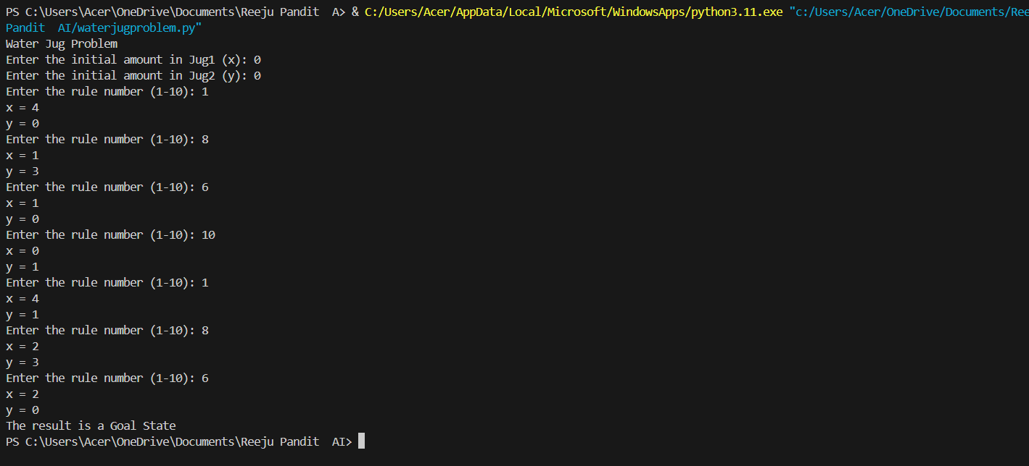

Compiler: Visual Studio Code
Language: Python

Simple ChatBot
# Simple Chatbot about IOST, TU courses
responses = {
"hello": "Hi! Welcome to IOST, TU course chatbot. How can I help you?",
"about": "The Institute of Science and Technology (IOST) is a constituent campus of Tribhuvan University (TU) that offers various undergraduate and graduate programs in science and technology.",
"courses": "We offer the following courses: Bachelor of Science in Computer Science and Information Technology (BSc CSIT), Bachelor of Science in Electronics and Communication Engineering (BSc ECE), Bachelor of Science in Civil Engineering (BSc CE), and more.",
"bsc csit": "Our BSc CSIT program is a four-year undergraduate degree that covers computer science and information technology. It includes courses on programming, data structures, algorithms, computer networks, and more.",
"bsc ece": "Our BSc ECE program is a four-year undergraduate degree that covers electronics and communication engineering. It includes courses on electronics, communication systems, microprocessors, and more.",
"bsc ce": "Our BSc CE program is a four-year undergraduate degree that covers civil engineering. It includes courses on structural analysis, transportation engineering, water resources engineering, and more.",
"masters": "We also offer various master's programs, including Master of Science in Computer Science and Information Technology (MSc CSIT), Master of Science in Electronics and Communication Engineering (MSc ECE), and more.",
"eligibility": "The eligibility criteria for our undergraduate programs is a minimum of 45% in 10+2 or equivalent in science stream. For master's programs, a bachelor's degree in a relevant field is required.",
"fee": "The course fee for our undergraduate programs is NPR 1,20,000 per year, and for master's programs, it is NPR 1,50,000 per year.",
"bsc csit fee": "The course fee for our BSc CSIT program is NPR 1,20,000 per year.",
"bsc ece fee": "The course fee for our BSc ECE program is NPR 1,20,000 per year.",
"bsc ce fee": "The course fee for our BSc CE program is NPR 1,20,000 per year.",
"msc csit fee": "The course fee for our MSc CSIT program is NPR 1,50,000 per year.",
"msc ece fee": "The course fee for our MSc ECE program is NPR 1,50,000 per year.",
"query": "Please ask your query, and I'll do my best to answer it."
}

def chatbot():
print("Welcome to IOST, TU course chatbot!")
while True:
user_input = input("You: ").lower()
if user_input in responses:
print("Chatbot:", responses[user_input])
elif user_input == "exit":
print("Chatbot: Goodbye!")
break
else:
print("Chatbot: Sorry, I didn't understand that. Please try again.")

chatbot()
Output:
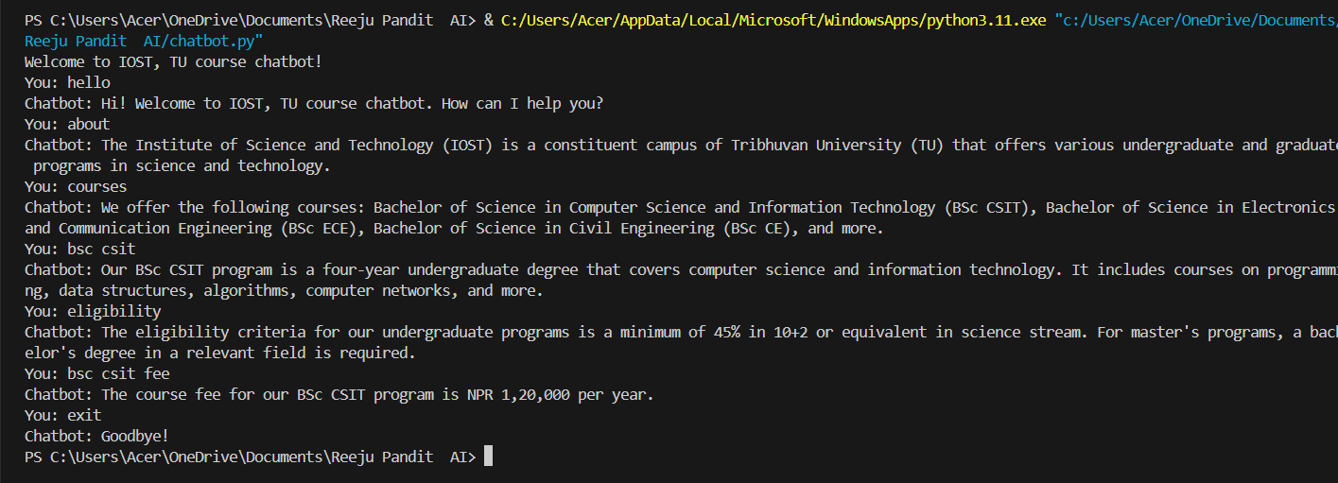
Compiler: Visual Studio Code
Language: Python

Breadth Search Frist
print(“Breadth First Search”)
from collections import deque
graph = { # Define the graph
'A': ['B', 'D', 'E'],
'B': ['C'],
'C': [],
'D': [],
'E': ['F'],
'F': ['G', 'H'],
'G': [],
'H': [],
}
def bfs_tree(graph, start):
visited = []
queue = deque([start])
parent = {start: None}
while queue:
node = queue.popleft()
if node not in visited:
visited.append(node)
print(node, end=" ")
for neighbour in graph[node]:
if neighbour not in visited:
queue.append(neighbour)
parent[neighbour] = node
return parent
def print_tree(parent, root):
print("\nTree structure:")
for node in parent:
if parent[node] is not None:
print(f"{parent[node]} -> {node}")

def main():
root_node = input("Enter the root node: ")
goal_node = input("Enter the goal node: ")
print("Following is the Breadth-First Search")
parent = bfs_tree(graph, root_node)
print_tree(parent, root_node)
# Additional logic to find the path from root to goal
path = []
current_node = goal_node
while current_node is not None:
path.append(current_node)
current_node = parent.get(current_node)
path.reverse()
print("Path from root to goal:", path)
if __name__ == "__main__":
main()
Output:
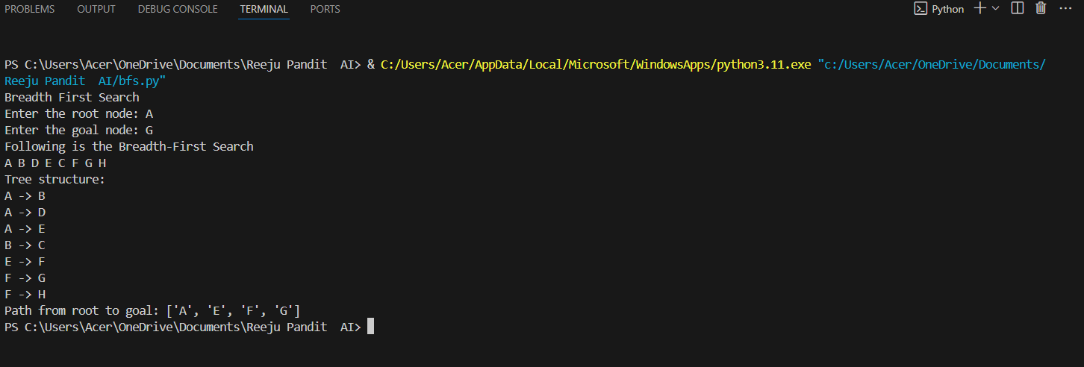
Compiler: Visual Studio Code
Language: Python

Best Search First:
print(“Best First Search”)
from queue import PriorityQueue
v = 14
graph = [[] for _ in range(v)]
def best_first_search(actual_src, target, n): # Function for implementing Best First Search
visited = [False] * n
pq = PriorityQueue()
pq.put((0, actual_src))
visited[actual_src] = True
while not pq.empty():
u = pq.get()[1]
print(u, end=" ") # Displaying the path having lowest cost
if u == target:
break
for v, c in graph[u]:
if not visited[v]:
visited[v] = True
pq.put((c, v))
print()

def addedge(x, y, cost): # Function for adding edges to the graph
graph[x].append((y, cost))
graph[y].append((x, cost))

addedge(0, 1, 3) # Adding edges to the graph
addedge(0, 2, 6)
addedge(0, 3, 5)
addedge(1, 4, 9)
addedge(1, 5, 8)
addedge(2, 6, 12)
addedge(2, 7, 14)
addedge(3, 8, 7)
addedge(8, 9, 5)
addedge(8, 10, 6)
addedge(9, 11, 1)
addedge(9, 12, 10)
addedge(9, 13, 2)

source = int(input("Enter the source node: ").strip()) # Asking user for source and target nodes
target = int(input("Enter the target node: ").strip())
if 0 <= source < v and 0 <= target < v: # Ensure the source and target are within the valid range
print(f"\nPerforming Best First Search from {source} to {target}:")
best_first_search(source, target, v)
else:
print("Invalid node values. Please enter values between 0 and", v-1)
Output:
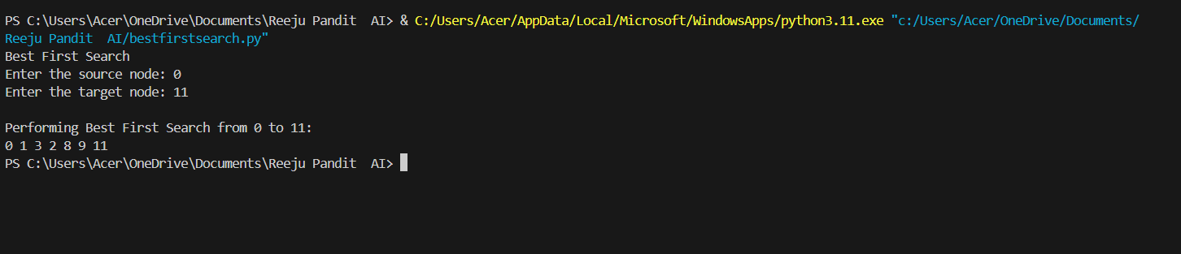
Compiler: Visual Studio Code
Language: Python
Depth First Search:
print(“Depth First Search”)
from collections import deque
# Define the graph
graph = {
'A': ['B', 'D', 'E'],
'B': ['C'],
'C': [],
'D': [],
'E': ['F'],
'F': ['G', 'H'],
'G': [],
'H': [],
}

def dfs_tree(graph, start):
visited = set()
stack = [start]
parent = {start: None}
while stack:
node = stack.pop()
if node not in visited:
visited.add(node)
print(node, end=" ")
for neighbour in graph[node]:
if neighbour not in visited:
stack.append(neighbour)
parent[neighbour] = node

return parent
def print_tree(parent, root):
print("\nTree structure:")
for node in parent:
if parent[node] is not None:
print(f"{parent[node]} -> {node}")

def main():
root_node = input("Enter the root node: ")
goal_node = input("Enter the goal node: ")
print("Following is the Depth-First Search")
parent = dfs_tree(graph, root_node)
print_tree(parent, root_node)
# Additional logic to find the path from root to goal
path = []
current_node = goal_node
while current_node is not None:
path.append(current_node)
current_node = parent.get(current_node)
path.reverse()
print("Path from root to goal:", path)
if __name__ == "__main__":
main()
Output:
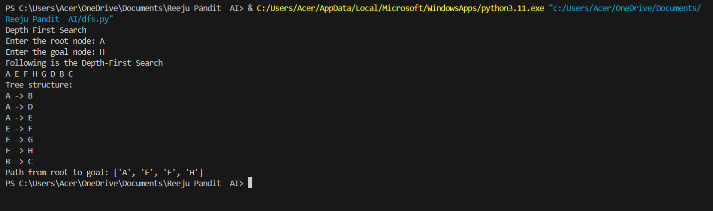
A* search:
print(“A* Search Algorithm ”)
import heapq
class Node:
def __init__(self, name, heuristic):
self.name = name
self.heuristic = heuristic
self.g = float('inf')
self.f = float('inf')
self.parent = None

def __lt__(self, other):
return self.f < other.f

def a_star_search(graph, start, goal):
start_node = Node(start, heuristic(graph, start, goal))
goal_node = Node(goal, 0)
open_list = []
closed_list = set()

heapq.heappush(open_list, start_node)

while open_list:
current_node = heapq.heappop(open_list)
closed_list.add(current_node.name)

if current_node.name == goal:
path = []
while current_node.parent:
path.append(current_node.name)
current_node = current_node.parent
path.append(start)
path.reverse()
return path

for neighbor, cost in graph[current_node.name].items():
if neighbor not in closed_list:
neighbor_node = Node(neighbor, heuristic(graph, neighbor, goal))
neighbor_node.g = current_node.g + cost
neighbor_node.f = neighbor_node.g + neighbor_node.heuristic
neighbor_node.parent = current_node
heapq.heappush(open_list, neighbor_node)

return None

def heuristic(graph, node, goal):
# Manhattan distance heuristic
return abs(ord(node) - ord(goal))

# Example graph
graph = {
'A': {'B': 1, 'C': 4},
'B': {'A': 1, 'D': 2, 'E': 5},
'C': {'A': 4, 'F': 3},
'D': {'B': 2},
'E': {'B': 5, 'F': 1},
'F': {'C': 3, 'E': 1}
}

start_node = input("Enter the starting node: ")
goal_node = input("Enter the goal node: ")

if start_node in graph and goal_node in graph:
path = a_star_search(graph, start_node, goal_node)
if path:
print("Path:", " -> ".join(path))
else:
print("No path found")
else:
print("Invalid node. Please enter a node that exists in the graph")

Output:
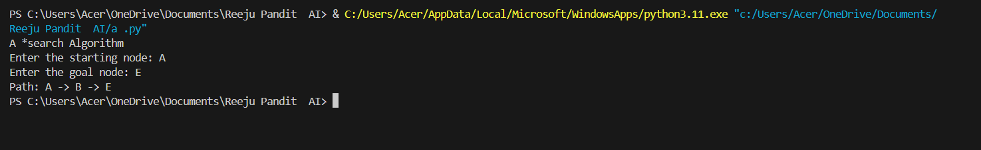
Compiler: Visual Studio Code
Language: Python

